SENSORS USED IN HEALTH CARE

**SENSORS IN HEALTHCARE ARE DEVICE THAT DETECT AND MEASURE BIOLOGICAL,PHYSICAL, OR CHEMICAL CHANGES IN THE HUMAN BODY AND CONVERT THEM INTO SIGNALS FOR DIAGNOSIS, MONITORING, OR TREATMENT.**

**TYPES OF SENSORS:**

* **TEMPERATURE SENSORS**
* **PULSE OXIMETER SENSORS**
* **RESPIRATORY/BREATHING SENSORS**
* **BLOOD GLUCOSE SENSORS**

**TEMPERATURE SENSOR:**

**DEFINITION: Device that measure body temperature and convert it into an electrical signal.**

**WORKING PRINCIPLE: Work based on change in resistance, voltage, or current due to temperature variations.**

**ADVANTAGES:**

* **Fast and accurate measurement.**
* **Non-invasive(infrared) or simple to use.**
* **Portable and low-cost**

**DISADVANTAGES:**

* **Skin temperature may not always represent core body temperature.**
* **Can be affected by environment(air, sweat ,etc..).**

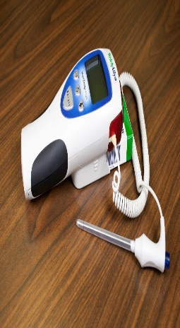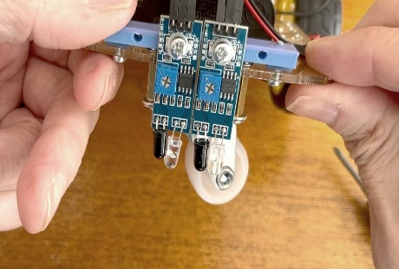

**TEMPERATURE SENSOR**

**PULSE OXIMETER SENSORS:**

**DEFINITION: Device that measure oxygen saturation(SpO2) and pulse rate.**

**WORKING PRINCIPLE: Use photoplethysmography(PPG)- red and infrared light are passed through a fingertip or earlobe, and difference in light absorptions by oxygenated vs deoxygenated hemoglobin are measured.**

**ADVANTAGES**

* **Non-invasive and painless.**
* **Provides real-time oxygen monitoring.**
* **Portable and easy to use.**

**DISADAVANTAGES**

* **Accuracy can be reduced by motion, nail polish, poor circulation, or bright light.**
* **Limited information(doesn’t measure CO2).**

**PULSE OXIMETER SENSOR**

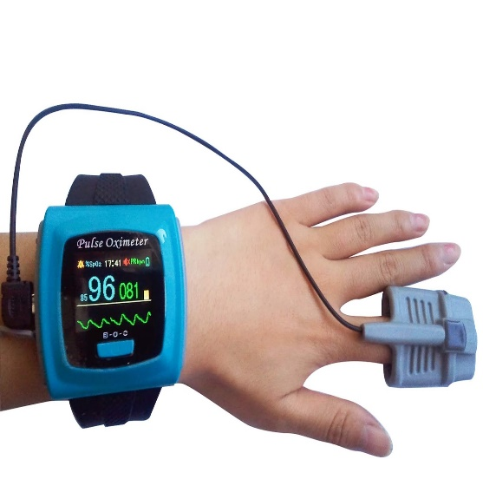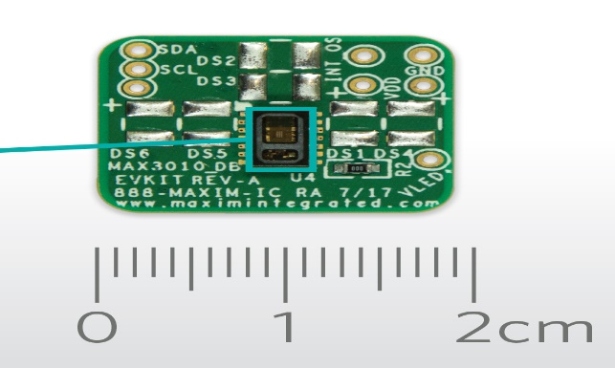

[This Photo](https://www.electronics-lab.com/tag/photodetector/) by Unknown Author is licensed under [CC BY-SA](https://creativecommons.org/licenses/by-sa/3.0/)

**RESPIRATORY/BREATHING SENSORS:**

**DEFINITION: Sensors that detect and monitor breathing rate and patterns.**

**WORKING PRINCIPLE: Strain gauges detect chest / abdominal expansion. Thermistor detect temperature difference in inhaled / exhaled air. Capacitive sensor detect air flow or chest movement.**

**ADVANTAGES:**

* **Non-invasive continuous monitoring.**
* **Useful for sleep apnea and lung disease monitoring.**

**DISADVANTAGES:**

* **Accuracy affected by body movement.**
* **May require calibration.**
* **Some types can be uncomfortable(wearable belt).**

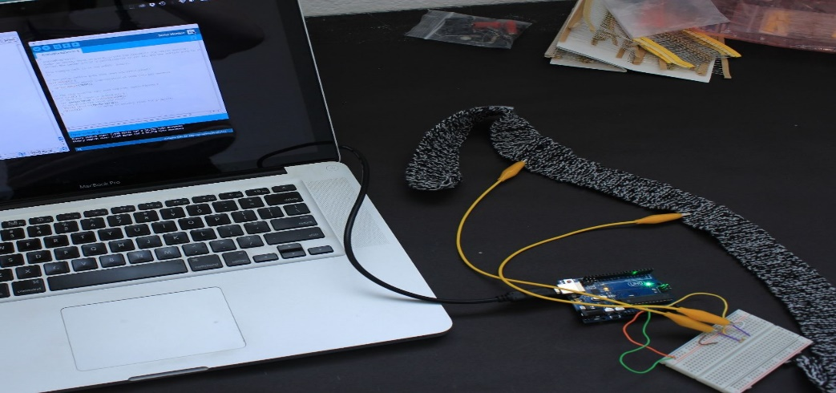

**BLOOD PRESSURE SENSOR:**

**DEFINITION: Device that measure the concentration of glucose in the blood, commonly used by diabetic patients.**

**WORKING PRINCIPLE: Electrochemical principle enzymes react with glucose producing electrons measured as electrical signals. Some newer sensors use optical / infrared methods.**

**ADVANTAGES:**

* **Provides critical data for diabetes management.**
* **Portable and gives quick results.**
* **Continuous glucose monitors reduce finger pricks.**

**DISADVANTAGES:**

* **Invasive(finger pricks or skin sensor)**
* **Sensor cost is high**
* **Accuracy may be affected by hydration, temperature, or pressure on the sensors.**

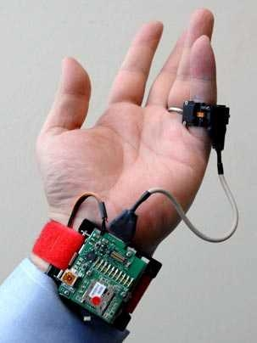

**CONCLUSION: HEALTHCARE SENSORS ARE FOUNDATIONAL TECHNOLOGY, PROVIDING REAL-TIME, CONTINOUS DATA FOR IMPROVED PATIENT MONITORING, EARLY DIAGNOSIS, AND PERSONALIZED TREATMENT, DRIVING ADVANCEMENTS THROUGH MINIATURIZATION, MULTIFUNCTIONALITY, AND AI INTEGRATION.**

